1.Create 2 triggers on emp table .

Trigger 1:

Before inserting any new record on emp table.

In the trigger body capture the action done in emp table into another

table named emplog having columns (serialno int autoincrement,

action varchar(100),actiondate_time datetime)

Serialno column to be incremented automatically and action to be

‘New Record Added to emp’ and actiondate_time should be current

date and time

Trigger 2:

After deleting any record from emp table.

Trigger body add record in emplog table with action ‘Record deleted

from EMP’. serialno autoincrement and actiondate_time should be

current date and time

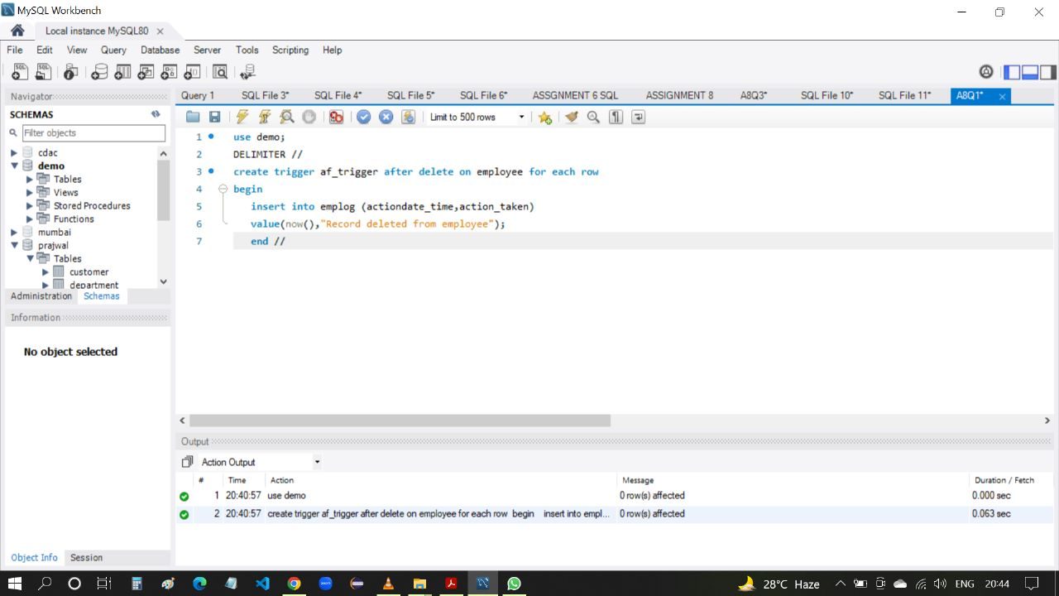

2. Try to capture exception handling in insert trigger such that no

duplicate record to be added.

Add that action also to emplog table with action ‘Trying to add

duplicate record’

